ICTWEB513 - Q1.14

# Table of contents

# 

**Table of contents** **2**

**Executive summary** **3**

**Usability tests** **4**

What is being tested: 4

Why it is being tested: 4

Results: 4

**Functional tests** **8**

What is being tested: 8

Why it is being tested: 8

[Results:  
Front-end](#_heading=h.jjo4glbwdh6q) 9

Back-end 12

**Compatibility Tests** **13**

What is being tested: 13

Why it is being tested: 13

Results: 14

**Database Tests** **18**

**Security tests** **19**

**Performance tests** **20**

# 

# Executive summary

This is a step-by-step manual document on testing the food recipes website.

# Usability tests

## What is being tested:

We are checking all the links and buttons.

## Why it is being tested:

We are testing the website against usability to identify issues and possible improvements on navigation flow and ease of use.

## Results:

The footer section of the home page links to a FAQ page but it is linked to the contact us page.

The other pages are correct.

**Steps to reproduce:**

1 - open the webpage in a browser

2 - on the home screen, click on the FAQ link, located at the bottom of the page

 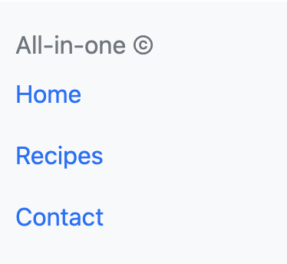

The components below are broken or have no functionality implemented:

* **Order now button**: it is not linked to any page or functionality and thus does not perform any action when clicked.  
  **Intended action**: open the page “order now” so it is possible to order the item referring to the card where the button is inserted  
  **Pages:** index.html, recipes.html  
    
  **Steps to reproduce:**1 - open the webpage in a browser  
  2 - on the home page, click the button order now  
  3 - click the link to the recipes page on the menu or footer  
  4 - on the recipes page, click the button order now  
  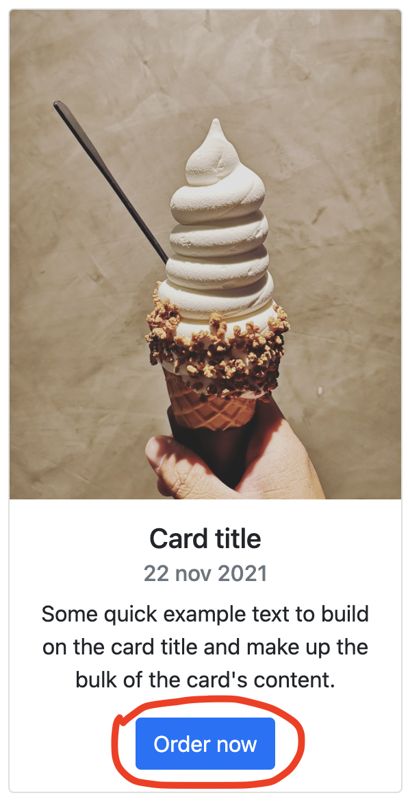
* **Filter buttons**: it is not linked to any page or functionality and thus does not perform any action when clicked.  
  **Intended action:** filter the current page's content by the selected filter.  
  **Pages:** recipes.htm  
    
  **Steps to reproduce:**  
  1 - open the webpage in a browser  
  2 - click on the recipes link on the menu or footer  
  3 - on the recipes page, click on any of the buttons on the grey row buttons

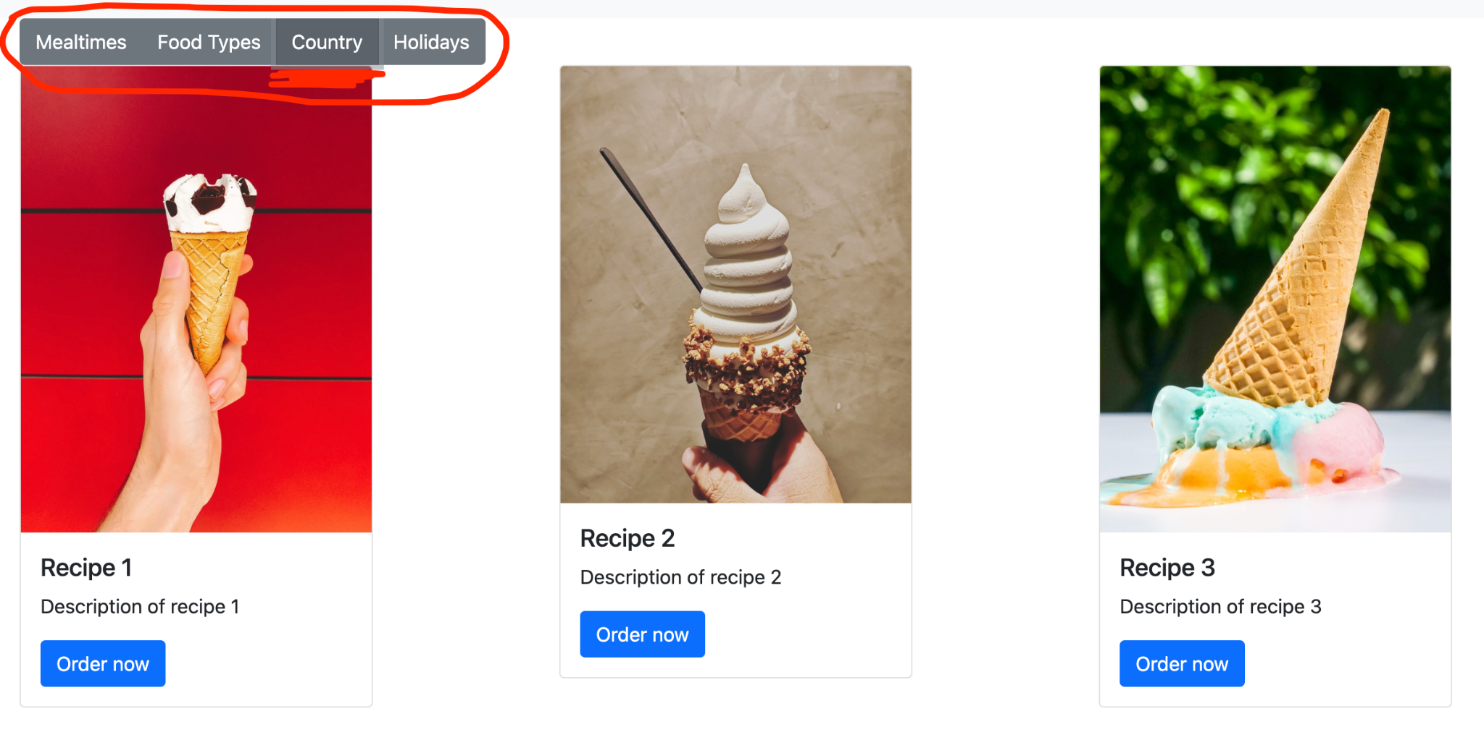

* **Send button:** the button is leading to an HTTP error 405  
  **Intended action:** submit the content of the form through email  
  **Pages:** contact.html  
    
  **Steps to reproduce:**  
  1 - open the webpage in a browser  
  2 - click on the contact us link on the menu or footer  
  3 - on the contact us page, click on send button located below the form fields

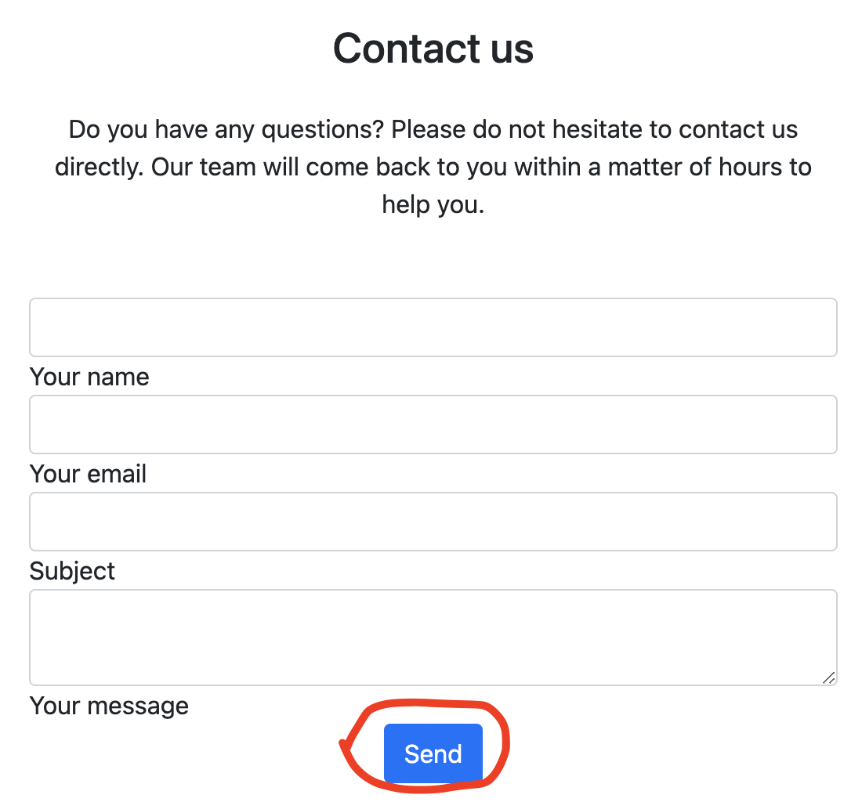 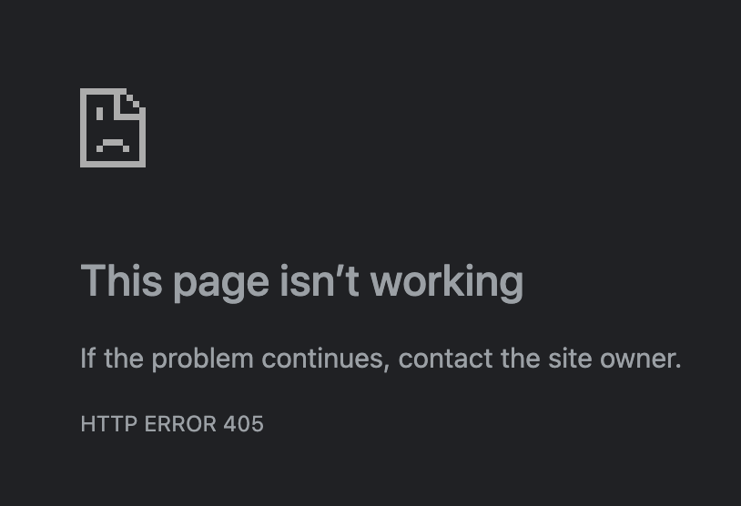

# Functional tests

## What is being tested:

We are verifying the website's functionality by testing its buttons and links and checking if the intended functionality happens.

## Why it is being tested:

Verify whether the product meets the intended functional specifications mentioned in the development documentation.

## 

## Results: Front-end

The component functionalities below are not yet implemented:

* **Order now button**: it is not linked to any page or functionality and thus does not perform any action when clicked.  
  **Intended action**: open the page “order now” so it is possible to order the item referring to the card where the button is inserted  
  **Pages:** index.html, recipes.html  
    
  **Steps to reproduce:**1 - open the webpage in a browser  
  2 - on the home page, click the button order now  
  3 - click the link to the recipes page on the menu or footer  
  4 - on the recipes page, click the button order now  
  
* **Filter buttons**: it is not linked to any page or functionality and thus does not perform any action when clicked.  
  **Intended action:** filter the current page's content by the selected filter.  
  **Pages:** recipes.htm  
    
  **Steps to reproduce:**  
  1 - open the webpage in a browser  
  2 - click on the recipes link on the menu or footer  
  3 - on the recipes page, click on any of the buttons on the grey row buttons

l

* **Send button:** the button is leading to an HTTP error 405  
  **Intended action:** submit the content of the form through email  
  **Pages:** contact.html  
    
  **Steps to reproduce:**  
  1 - open the webpage in a browser  
  2 - click on the contact us link on the menu or footer  
  3 - on the contact us page, click on send button located below the form fields



## 

## Back-end

The current version of the website has no back-end implemented.

# Compatibility Tests

In order to determine if your software is compatible with other elements of a system with which it should operate, e.g., Browsers, Operating Systems, or hardware, we are running compatibility tests.

## What is being tested:

Compatibility of the website.

## Why it is being tested:

To determine if the website is compatible with other elements of a system with which it should operate, e.g., Browsers, Operating Systems, or hardware.

## 

## Results:

Chrome - ok

**Steps to reproduce:**Open the website on Chrome browser

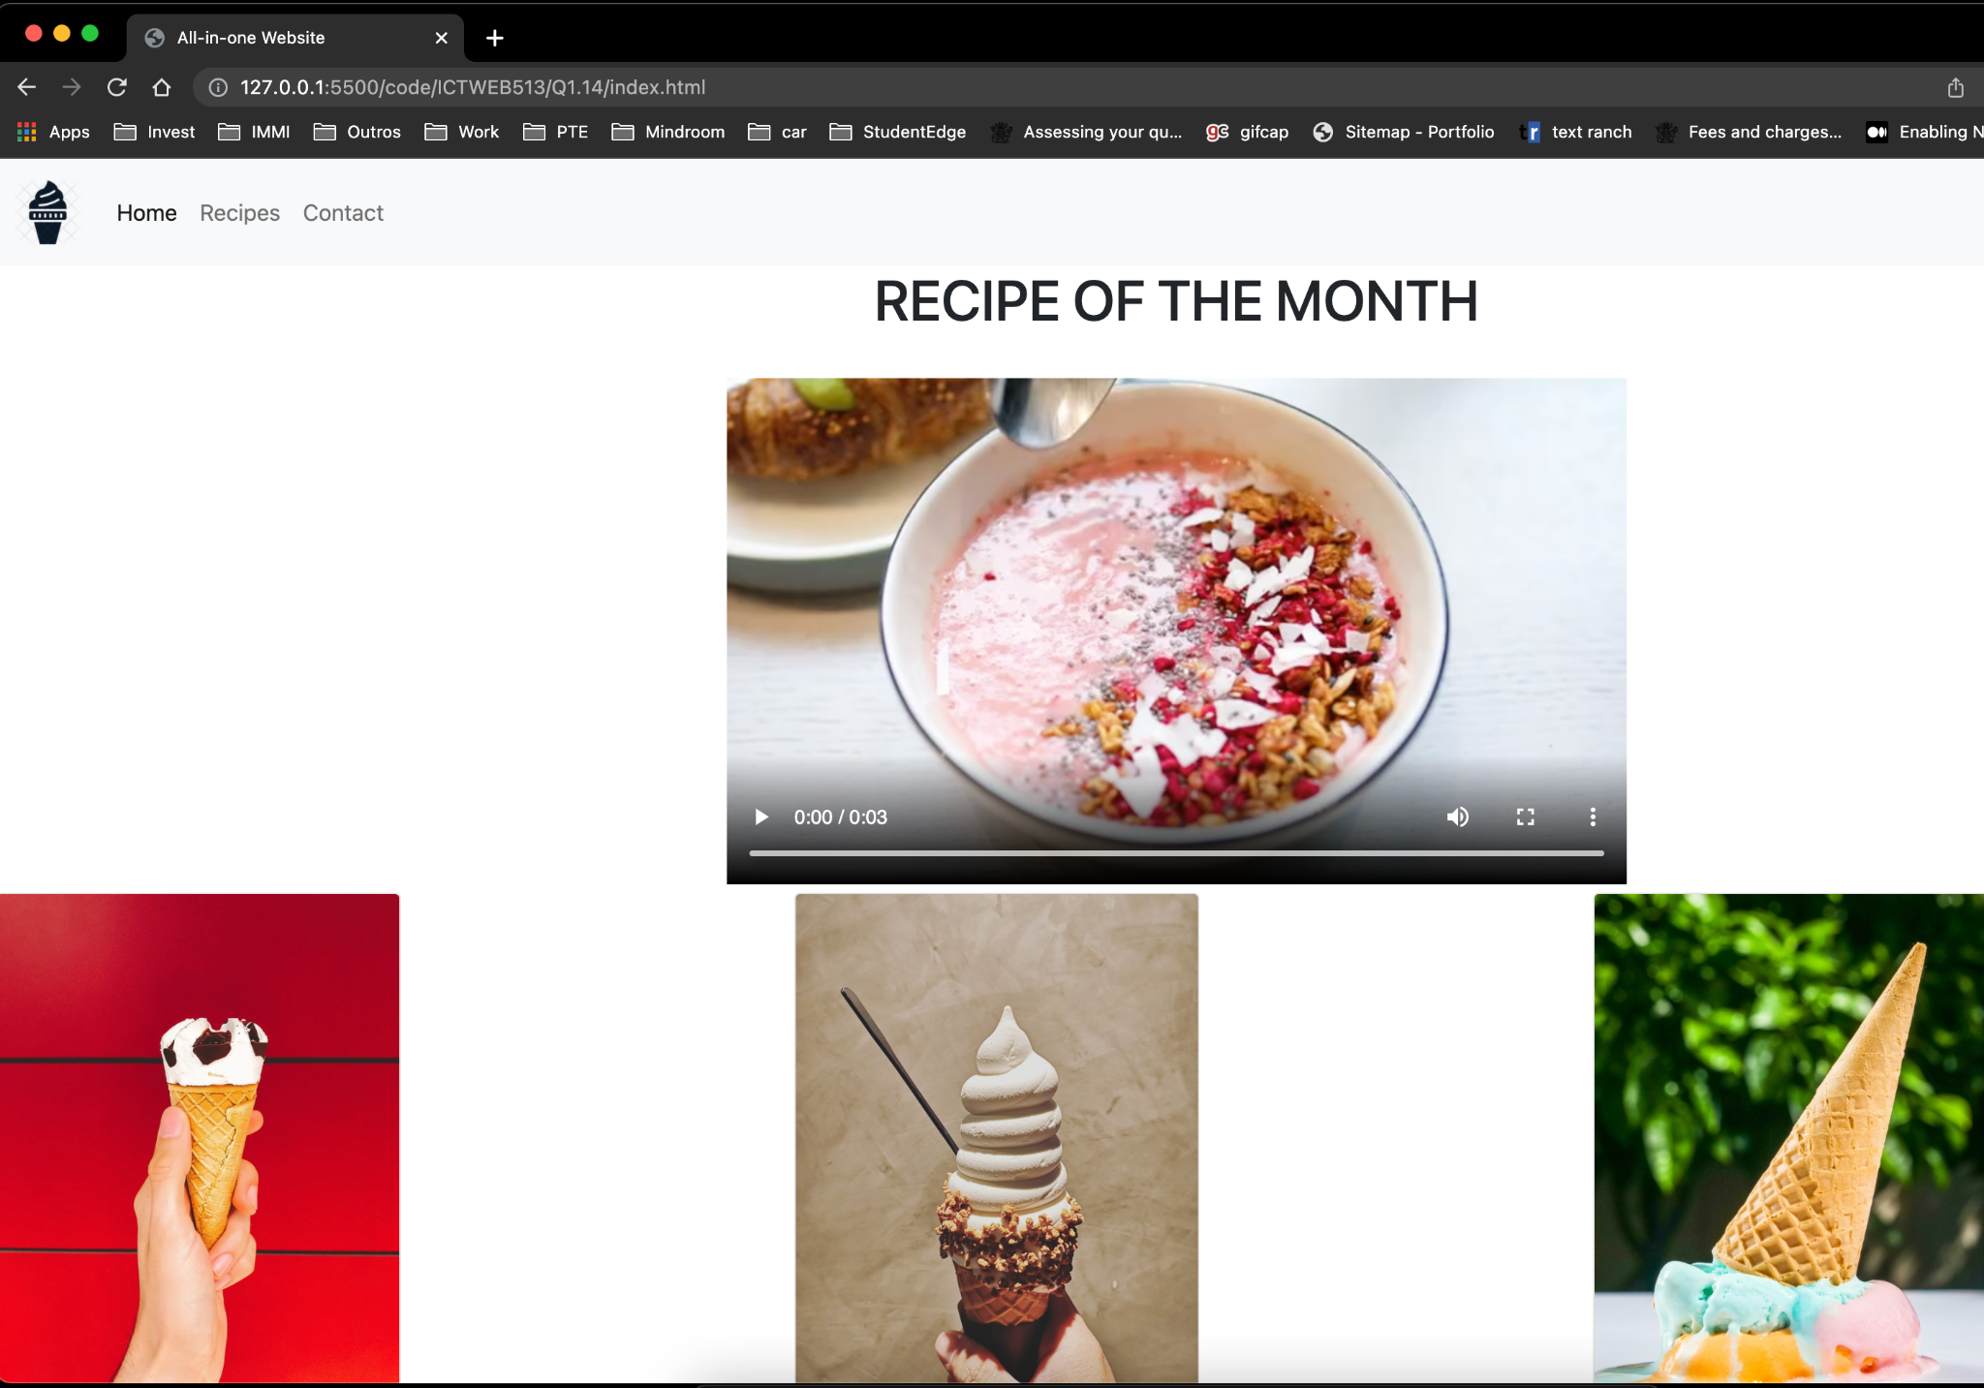

Safari - ok

**Steps to reproduce:**Open the website on the Safari browser

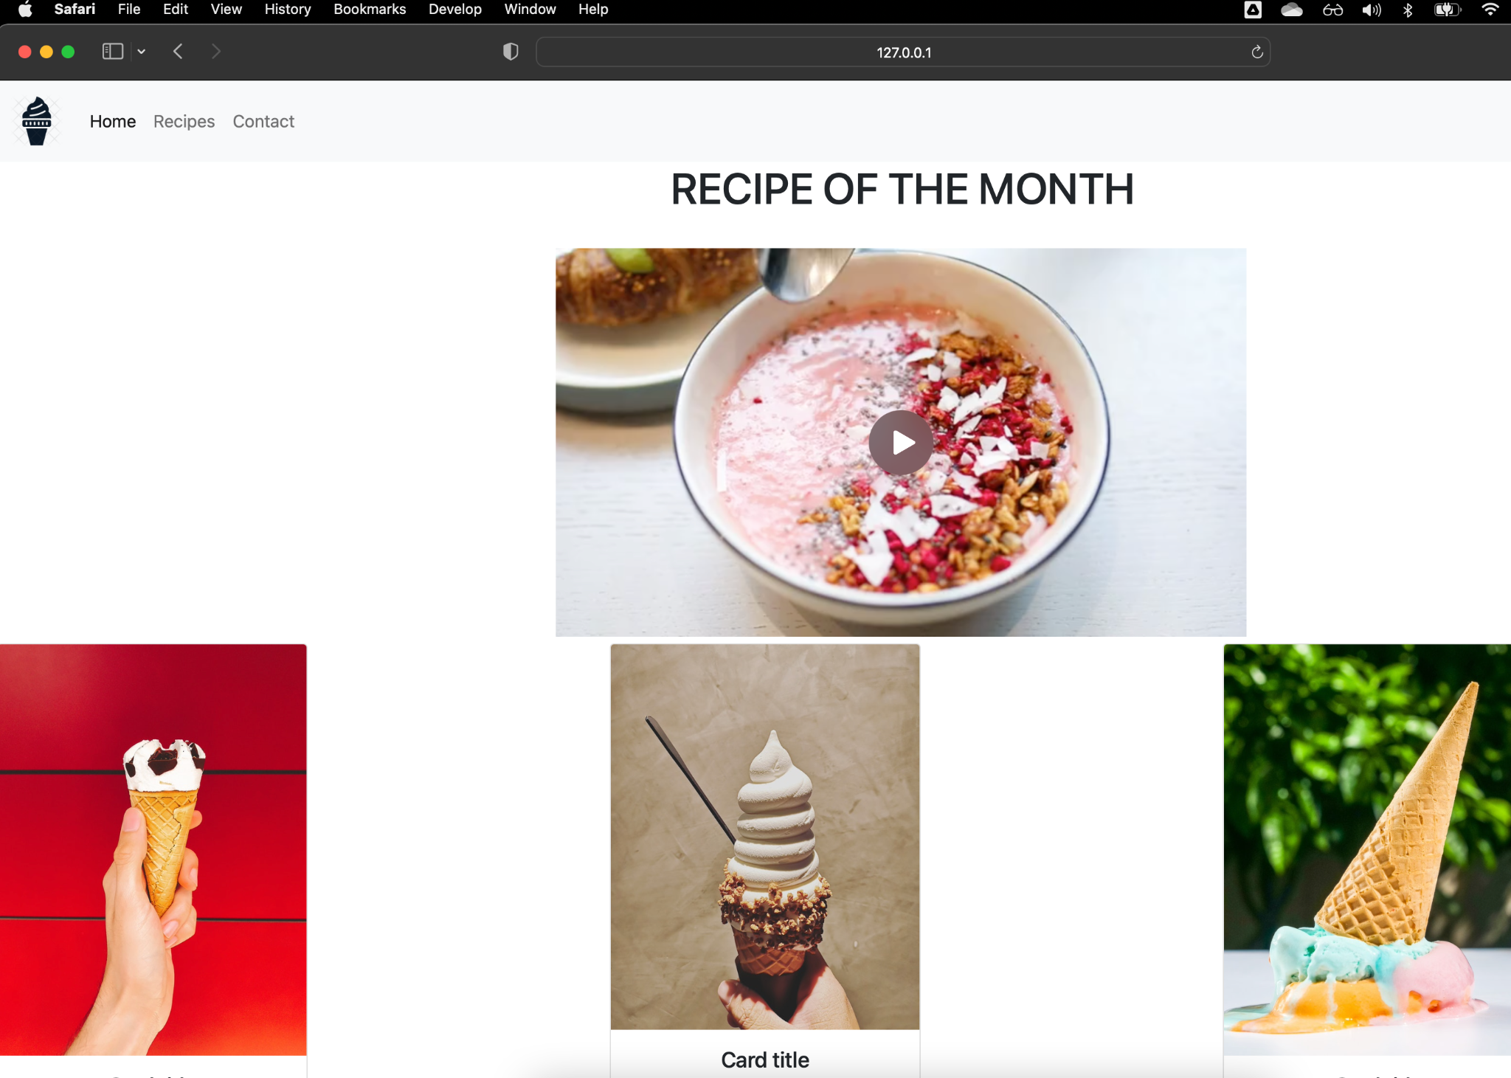

Mobile - not ok

Video extrapolate the size of the screen or the other components padding is incorrect:

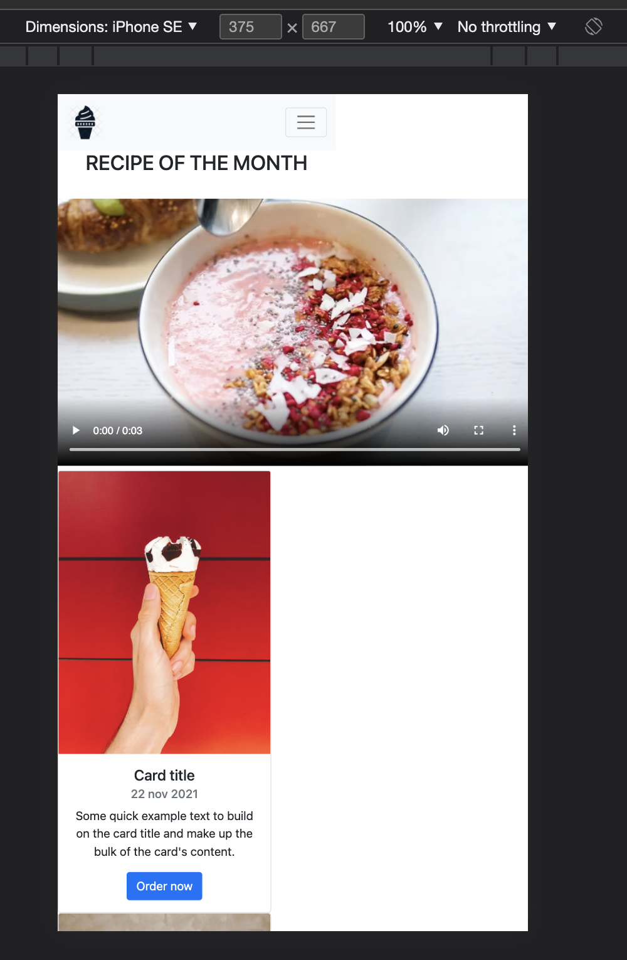

**Steps to reproduce:**1 - Open the website on Chrome browser

2 - press F12 to open dev tools

3 - click toggle device toolbar  
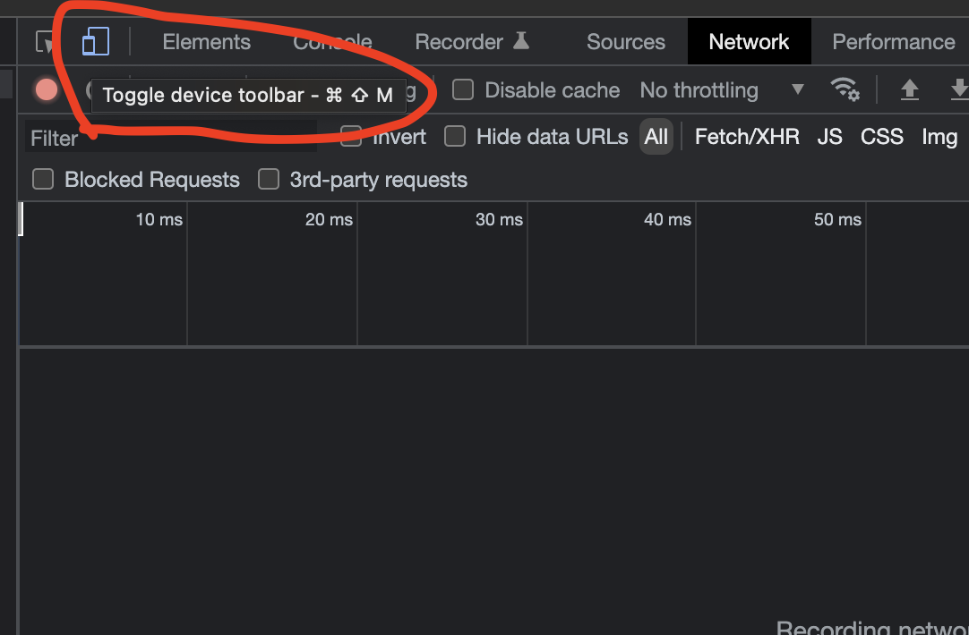

4 - Select the desired device(mobile):

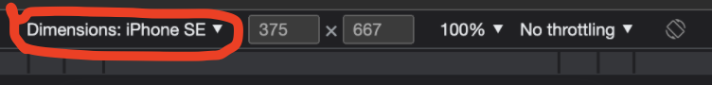

# Database Tests

The current version of the website does not have a database.

# Security tests

The current version of the website does not have any sensitive data or security issues.

# 

# Performance tests

The current version of the website is not available online, only local, therefore, we run no performance tests.